AXLR8 WordPress Job Board Plugin Guide

What is the plug in for?
The AXLR8 ATS Job (Applicant Tracking System) posting plugin allows you to display jobs that have been entered in AXLR8 ATS on your public Wordpress website. This starts a great applicant journey that is efficient to manage for your Talent management team.

The AXLR8 ATS includes a Job Posting function. You can create a job with all the details you would like your candidates to see and then link it with an initial application form (AF). This form would probably have been built in AXLR8 AFB (application form builder) which is integrated into the ATS. This Job Posting mechanism allows recruiters to spread their net wide by creating a Job Position once and selecting one or more places to post the job – one of which is the company Wordpress website.

Who Is this document for?
Wordpress web designers. These instructions are aimed at web designers who need to provide an automatically updating web page of job adverts for their client using an AXLR8 ATS. The plug in is for Wordpress. We have not created one for other CMSs available (Joomla, etc.) but would consider it either as a paid custom project or according to market footprint.

The client (i.e. employer/ recruiter) will load the jobs on their system and, subject to management approval, the job advert details will appear in an API endpoint containing all the data. You can either program your website by hand to read the XML and formatting or this plug in will do that for you.

References
- AXLR8 Staffing general website (full of resources) https://staffing.axlr8.com
- Companion document linked here about how to advertise jobs on Indeed and other posting boards https://staffing.axlr8.com/axlr8-indeed-link-explained/
- Integration with Willo one-way interview software: https://staffing.axlr8.com/willo-integration/ and several other partners.

Help and Support
Please call +44 1344 776500 or email us support@axlr8.com and we will be delighted to help you make your employer’s / client’s project a great success and hopefully a fantastic reference site for both of us.

Definitions
In dealing with any business automation, it is important to agree specific terms and vocabulary.

Term | Meaning, examples & notes
ATS | Applicant Tracking System This describes a system that helps recruiters with functionality including application forms, job advert postings, management information and reports. It also encompasses workflow automation such as emails and texts with templated for different functions. These can run with and without human intervention.
Job Board | Also called a Careers Page or Vacancies Page, it will have a list of jobs being advertised. Clicking on any job should take you to the Job Details in the Job Advert Page – normally with an “Apply Now” butonate the bottom and
Job Position | Often abbreviated to JP this is a position or vacancy for which you may have several candidates and applications. It may be advertised on several websites and job boards (referred to as Job Advertising Media).
Job Post | Normally the same as a vacancy or position except that you may have several positions available in one post or you may make several Job Posts but in different regions for effectively the same position.  The system allocates a Job Post ID and you can track who has applied for what Job Post.
Source Tracking | Any candidate who begins an application form will have landed from a source and the system provides tokens you can use to measure what they are applying for and how they heard about you. This information is invaluable for planning future recruitment strategy.
JAM | Job Advertising Medium. For example, your website, your company intranet, your local paper, Indeed, Monster, Facebook, Linked In, etc. Each may have a cost and it is important to track which ones bring the candidates to you most effectively.
Job Advert | This is an advertisement published on a JAM. AXLR8 allows you to create several JAMs and measure which are successful. This is important for many reasons – not least because charges may be associated with advertising or some media owners may share your applicants with your competitors.
De-duplication | In any recruitment system there will be people who apply more than once – through e.g. simple error or in order to frustrate a decision not to rehire that individual due to previous behaviour. In AXLR8 some options include email address, cell number and NI number as fields to check.
Job Type | There are ways to group job postings in AXLR8 and you can even put them in different pages on your website. For example, Permanent and Temporary or Security and Cleaning. Each might have a different candidate journey, qualifications, vetting process and hiring manager. These are sometimes also called Job Categories
Region | There are different ways to categorise jobs and regional organisations are often defined, e.g., North and South
Job Details | This is a generic term which covers lots of very specifically defined fields in the system including, for example, Job Title, description, goals, expected required qualifications /experience, region, category, pay rate, reporting manager, etc.
JAS | Job Application Status is best defined as the stage that any candidate is at in the hiring process. It will be used for reporting and also may trigger actions such as invitations to interview or to fill out a more detailed second form.
AFB | Application form builder allows you to create and edit multiple application forms for different applicant journeys. For example, you may have a very brief form at first then those candidates selected to go further will be asked to fill in a more detailed second form. The AFB can also design forms for collecting post hiring details such as bank account details for payment but this is normally accomplished using the AXLR8 Staff app.
Triggers | This refers to events where you want some automated task to launch Normally this would be an email launched in Trigaware™. It might be an acknowledgement of application or an invitation to interview or confirmation of employment with links to log in and upload data about pay.
Application form | The AFB allows you to create one or more application forms which the candidate fills out. These may be on your email signature block, your website or any other medium (JAM)
Contact Created | This is normally the first stage of a job application. We call these stages a JAS or Job Application Status. Sometimes a candidate creates an account by providing their email and name on the front page and does not complete the form. You can still see their contact details and either ignore them or follow up to see why they did not progress further or simply have automated email triggers to remind them.
Privacy Policy/Agreement | You will have a privacy agreement available for your application forms linked on your website which states what data you will collect at each stage and why you will need it and it will also detail when you will destroy it. Obviously, the retention rules will differ between unsuccessful candidates and those who begin employment. It is not a subject for this document but this is essential for GDPR and the agreement may be associated with a custom automated deletion process for candidates’ private data after certain periods.
Application | This means an application form completed and the candidate has now completed their first application form. Once a recruitment manager (or a GDPR retention rules engine) deletes the candidate details, you may see the Application data still for management information. However, the candidate’s private details will be absent.  Depending on your applicant journey plan, this could be for one job or many.  Typically, a candidate would apply for one job position but you can allow people to show interest in more than one.

Finally, when we refer to the client/employer we mean the company who employs you to design and maintain their website.

Installing the plugin
The plugin will be sent in a .zip file. Unzip the file and upload the folder entitled Axlr8WftJobPostList to /wp-content/plugins/ folder via your chosen ftp client.

Within Wordpress, go to Plugins on the left hand menu and click Activate for the AXLR8 WFT Job Post List Plugin.

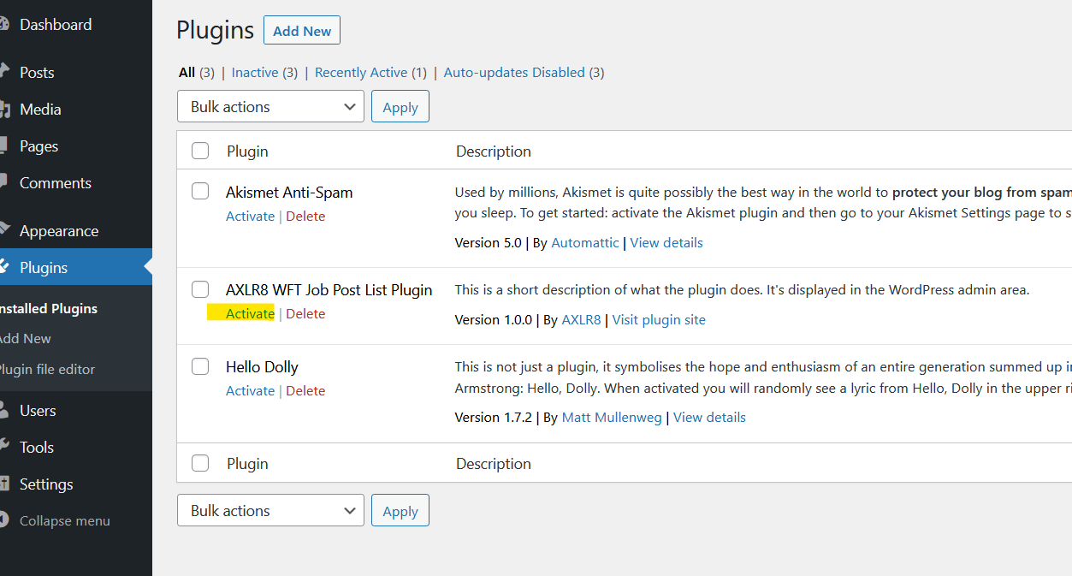

Once activated, a new menu item will appear on the left hand menu – AXLR8 WFT Job Post List Plugin. Click on this in order to enter the URL of the site from where the job posts will originate.

If you have not been an endpoint URL for this field, please contact your client who will obtain it from AXLR8 or authorise us to send it to you.

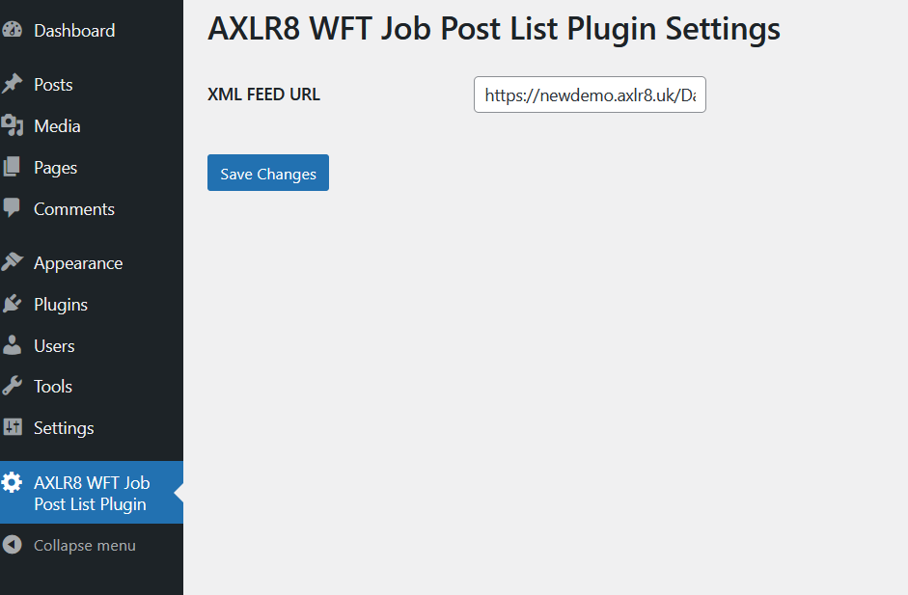

https://newdemo.axlr8.uk/Data/jobPostDocs/fullPost/fullJobs.xml is the URL entered in the above example. DO NOT USE THIS URL which is for our demo system

Substitute your own URL stub in place of https://newdemo.axlr8.uk, ensuring that the remainder of the URL remains, and click Save Changes.

You now need to identify the page on which the jobs are to be displayed. Edit the appropriate page and paste in the shortcode  [axlr8_wft_getjobpostlist] | 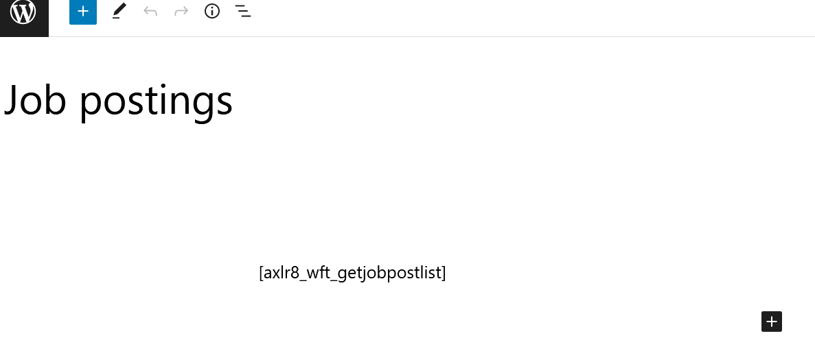

Multiple job Board pages
In future versions, there will several more parameters. For example, if you want two pages (one for South and one for North Job Advertisements or one for Temp and one for Perm jobs), we are planning a way to filter the jobs on each Job Board page you create. Thus, as an example, if you have catering and cleaning jobs, you could say only show catering Jobs on the Hospitality job board and likewise only cleaning jobs would appear on the Cleaning job board.
Each type of job would have a different format and you may want different application forms and different applicant journeys. This is certainly the case where there are different compliance requirements – e.g. Stewards and Security guards and Door Supervisors.

You will now see any job posts entered on the system displayed on this page in a web browser.

Styling the display

The custom CSS can be used within Wordpress for any styling changes you wish to make.

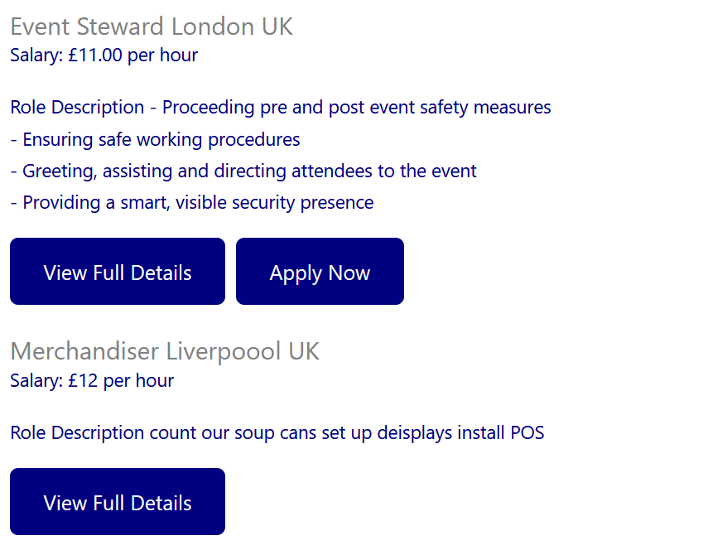

In the above example, the classes are as follows:
Job name class = .axlr8WftJobListItem h1 (set to {color:grey;font-size:24px;})
Job Item class = .axlr8WftJobListItem p (set to {color:navy;font-size:18px; padding-bottom:20px})
Button id = button (set to {background-color: navy !important; border-radius: 8px; padding: 0px -10px -10px -10px ;}

.axlr8WftJobPostListResults
.axlr8WftJobPostListItemButtons

Troubleshooting
Sometimes the Jobs do not come back on your test or live career page. Here are some things you can check

Publish Jobs
Have the employing company actually approved, saved and published one or two jobs to test they come through to your test page?
This needs to be done with at least some of the individual field “ticked”.

URL Check
There are several things you can try if the page(s) do not come back in your new careers page.
Try the URL to make sure it is typed correctly and works. Not just the one we gave you but the one that you pasted into your AXLR8 plug-in.

https://<yourcompanycode>.axlr8.uk/Data/jobPostDocs/fullPost/fullJobs.xml

It should bring back an XML stream of published jobs and all their details and links for, e.g., the chosen application form for that job.

Check your code
If you are familiar with PHP, you can check the code.

function renderJobListJson($url) {
$jobsArr = array();

$doc = new DOMDocument();
$doc->load($url);

$jobs = $doc->getElementsByTagName("job");
foreach ($jobs as $xmlJobPost) {
$jobsArr[] = loopJob($xmlJobPost);
}

return $jobsArr;
}

Turning on Wordpress debugging

You can turn on Wordpress debugging by changing the parameter wp_debug in wp-config.php from “false” as shown here to “true” for a while. This is shown in the screenshot below and it provides some verbose messages.
In the example below (with client information replaced, we discovered it was a mistyped URL and looped back through 8.2 above.

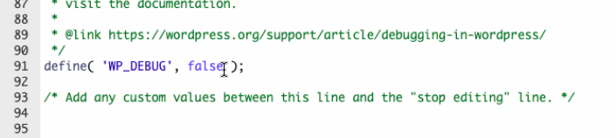

On our "Test" page the following or similar will give you a clue as to what has gone wrong. In the case below, it was a typo in the XML URL (endpoint for the API).

Test

Warning: DOMDocument::load(): php_network_getaddresses: getaddrinfo failed: Name or service not known in /home/b6o9mwbh7xe7/public_html/<companydomainname>/wp-content/plugins/Axlr8WftJobPostList/shortcode/shortcode-axlr8-wft-getjobpostlist.php on line 78

Warning: DOMDocument::load(https://<yourcompanycode>.axlr8.uk/Data/jobPostDocs/fullPost/fullJobs.xml): failed to open stream: php_network_getaddresses: getaddrinfo failed: Name or service not known in /home/b6o9mwbh7xe7/public_html/<companydomainname>/wp-content/plugins/Axlr8WftJobPostList/shortcode/shortcode-axlr8-wft-getjobpostlist.php on line 78

Warning: DOMDocument::load(): I/O warning : failed to load external entity "https://<yourcompanycode>.axlr8.uk/Data/jobPostDocs/fullPost/fullJobs.xml" in /home/b6o9mwbh7xe7/public_html/<companydomainname>/wp-content/plugins/Axlr8WftJobPostList/shortcode/shortcode-axlr8-wft-getjobpostlist.php on line 78

In this case, we see the URL for the XML is not recognised: “……..failed: Name or service not known……”.
This is the most common issue.

Plugin include code
Make sure the call to the plugin is formed correctly on the page you wan it to come back on. We have discovered that different page editors may have different behaviour (DIVI, Elementor, etc.)

Call AXLR8 Support Helpdesk
If all the above fail, please call +44 1344 776500 or email us support@axlr8.com and we will be delighted to help you make your employer’s / client’s project a great success and hopefully a fantastic reference site for both of us.

Feedback
If you have any ideas about how we can improve, we would be most grateful.

Thanks
We would like to thank several great web design companies and clients who have helped us on this journey. TechoWeb, Doc&Tee, Design8. All have provided a great result for their client and given us fantastic feedback.

